Project Design Phase-I Problem Solution Fit

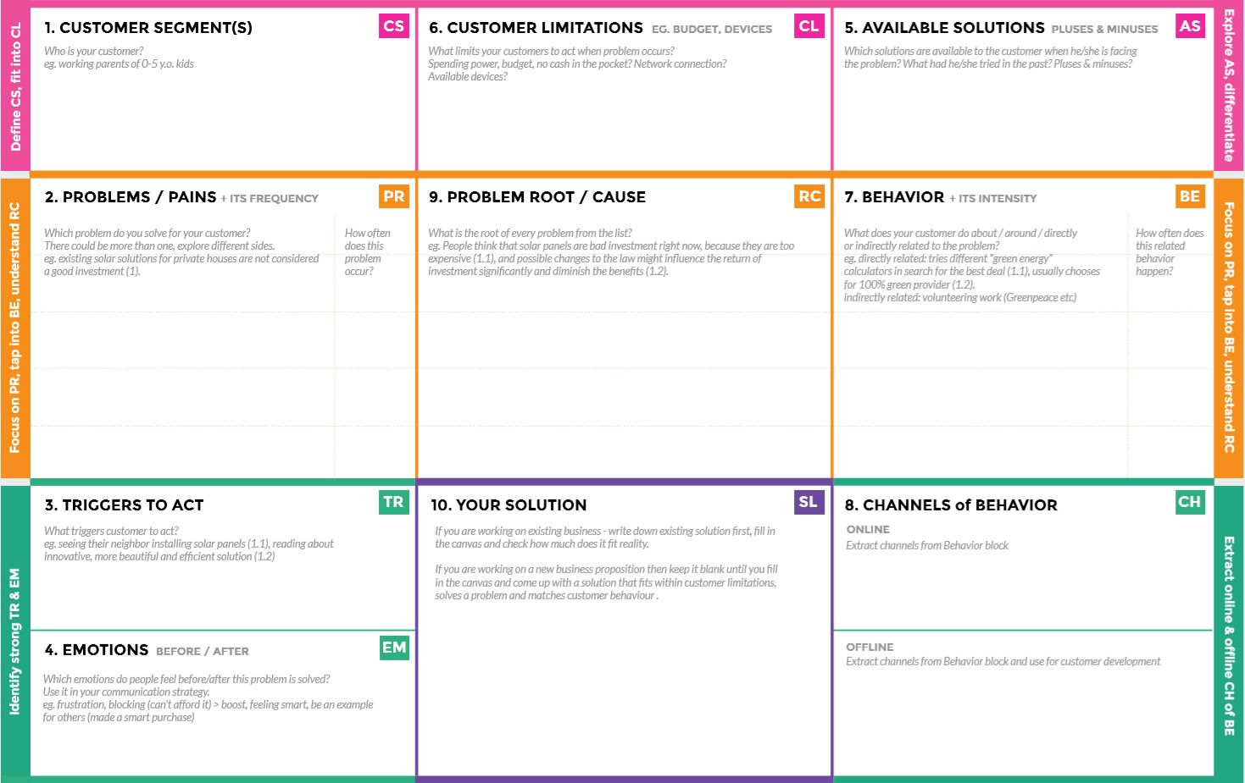

**BEFORE**: Finance, jobless and conflict in relationship.

**AFTER:**If you get work to fix the problem

**OFFLINE**: Search through classifieds for jobs that match your skills

**ONLINE:** Job seekers must understand the company's requirement well and search accordingly

**“cloud application development based job/ skill recommender for job seekers” !!**

It suggests suitable jobs as soon as possible according to the skills of the job seeker

Create more job opportunities to lift people out of poverty in developing nations.

**Direct related**: Tries to find a solution to prevent this problem

**Indirect related**: Located in rural where internet connectivity might not be strong enough to facilitate fast transmission speeds.

1. As unemployment has increased, competition for jobs has increased
2. Companies are looking for highly skilled workers

* It’s difficult to find more jobs
* Isn’t known if the application doesn’t work properly.

can use computer and mobile applications that provide a lot of work

1)High adoption costs , security concerns. 2)Not aware of the implementation of cloud applications

Job seekers

|  |  |
| --- | --- |
| Date | 19 September 2022 |
| Team ID | PNT2022TMID36837 |
| Project Name | Skills and job recommender Application |
| Maximum Marks | 2 Marks |